Business Services Accountant – Graduate
Position Title | BSA - Graduate
Employment Type | Full Time
Salary | $60-65k + Super
Location | Norwest, Sydney
Commencement | Immediate Start
Reviewed By | Principal Partner & People and Culture Manager

About M G Arthur & Associates
We are an award-winning high performing accounting firm, where highly skilled Professional Advisors specialise in business accounting, tax and SMSF consultancy, dedicated to delivering exceptional value to their HNWIs and SMEs. With decades of combined experience, we play a pivotal role in helping clients achieve their financial goals in today's dynamic business landscape. We have a strong track record of taking on graduates and career starters with little or no local experience and developing them into exceptional tax accountants – this role is the next chapter in that story.
The energy and enthusiasm our team brings make our office a pleasant and rewarding place to work. Our workplace culture is built on integrity, respect, teamwork and continuous improvement, with a close eye on the well-being of team members. We recognise team members for their leadership at every level, encourage both professional and personal growth and provide mentorship. Free from negativity, we enjoy regular team building activities, great collaboration and flexibility. Careers thrive here!
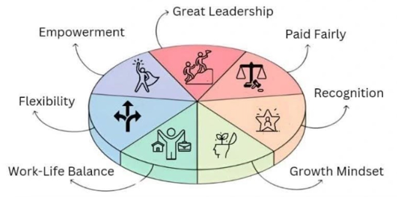 Join us and Complete your Pie

Position Purpose
The primary purpose of the Business Services Accountant - Graduate is to run the Corporate Secretarial Services umbrella while supporting a team of accountants and managers to effectively provide exceptional client service, while developing the technical and professional skills needed to progress within the firm.

Reporting Relationships
Reports to Manager and Partner

Stakeholders
- Partners
- Sydney Accounting & Admin Team
- Overseas Accounting & Admin Team
- Clients
- Third party external providers

How you will contribute to the team
- Execute and manage the Corporate Secretarial Service in the formation of companies, trusts and SMSFs, and maintain related documentation, including updating ABR & ASIC with various changes eg. Shareholders, address, etc. - supported by an offshore team (a strong foundation for the rest of your career – and a skill most experienced accountants lack).
- Assist in the preparation of financial statements, income tax returns and loan summaries for individuals, companies, trusts and partnerships, under supervision.
- Assist with basic BAS/IAS preparation and GST reconciliations.
- Work closely with Managing Partner on his most critical work – liaising with clients, lawyers and other key stakeholders.
- Working as part of a team where you will work closely with, and be mentored by, other intermediate and senior business services accountants.
- Build proficiency in software such as MYOB Suite, Xero and CAS360.
- Support the team with client correspondence and liaison with external service providers, under guidance.

What makes you a great fit
- 0-1 years' experience in public practice, or a recent accounting/commerce graduate – we welcome career starters with no local (Australian) experience.
- Have the desire and ability to provide exceptional client service with a passion for tax.
- Have excellent communication skills both verbal and written.
- Have strong problem solving skills with high attention to detail - technical dept is trained on the job.
- Fast fingers and a faster mind – a quick learner who thinks outside the box, with an appetite for self-learning and the maturity to know what's critical and prioritise accordingly.
- Foundational understanding of Australian Tax Law, with an eagerness to build hands-on experience in personal income tax, small business tax, capital gains tax, taxation for trusts and companies and GST.
- Studying towards, or about to start, the CA / CPA program.
- Keen to build proficiency with Xero, XPM and Xero Tax, working towards Xero and Xero payroll certification.
- You're confident with core accounting concepts and comfortable preparing journal entries.

What You Will Get
- A rare, hands-on opportunity to build your career from the ground up, working closely with the Managing Partner.
- A supportive, collaborative, and tech-driven work environment that encourages your personal and professional growth with complete transparency.
- Competitive compensation and benefits, including a base salary, superannuation, and the potential for an annual bonus based on individual performance metrics.
- Thriving career, contributing to our mission of delivering exceptional value to clients.
- Receive CA/CPA mentorship from experienced professionals, allowing you to learn from the best in the field and grow your expertise.
- Access to ongoing in-house and external CPD training, ensuring continuous professional development and keeping you up to date with the latest industry practices.

